Enclosure Fire Dynamics:
A collection of equations, tables and figures
Pool fire 2
Fire Plumes and Flame Heights 2
The Zukoski Plume 2
The Heskestad Plume 2
The Thomas Plume 2
Line Source Plume 2
Ceiling Jet 3
Flame Extensions Under Ceilings 3
Pressure Profiles and Vent Flows, Well-Ventilated Enclosures 3
The Well-Mixed Case 3
Taking into Account the Mass Produced in the Room 4
The Stratified Case 4
Mass Flow out through a Ceiling Vent 4
Gas Temperatures in Ventilated Enclosure Fires 4
Predicting time to Flashover 4
The Energy and Mass Balance 5
Conservation Equations and Smoke Filling 5
The Conservation of Energy 5
Smoke filling of an Enclosure with Leaks 5
Estimating Gas Temperature for the Floor Leak Case 6
Smoke Control in Large Places 6
Natural Ventilation from Upper Layer 6
Lower layer Pressurization by Mechanical Ventilation 7
Combustion Products 7

BK,061015 / HA, 071023
Pool fire
Energy release rate: 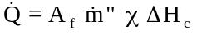 (3.5)
Mass loss rate: 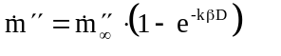 (3.6)

Fire Plumes and Flame Heights
Flame height: 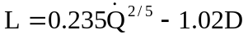 (4.3)
Continuity equation: 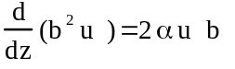 (4.10)
Momentum-boyancy equation: 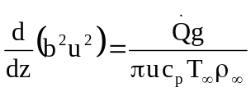 (4.13)

The Zukoski Plume
Mass flow equation: 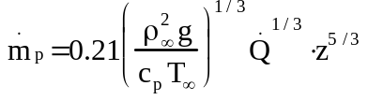 (4.21)

The Heskestad Plume
Virtual origin: 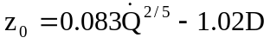 (4.23)
Plume radius: 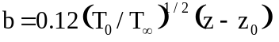 (4.24)
Centerline temperature: 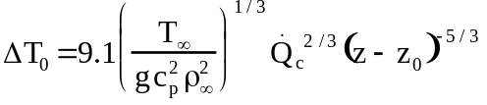 (4.25)
Centerline velocity: 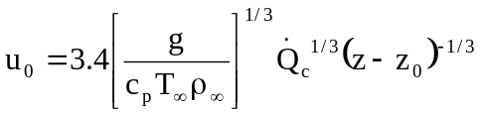 (4.26)
Plume mass flow rates:
For z > L: 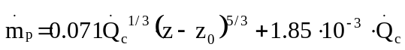 (4.27)
For z < L: 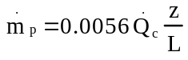 (4.28)

The Thomas Plume
Mass flow rate: 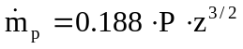 (4.31)

Line Source Plume
Flame height: 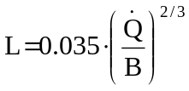 (4.34)
Mass flow rate: 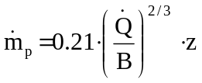 (4.35)

Ceiling Jet
For r/H < 0.18: 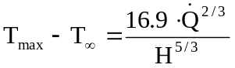 (4.36)
For r/H > 0.18: 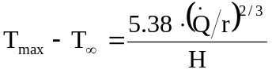 (4.37)
For r/H < 0.15: 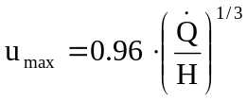 (4.38)
For r/H > 0.15: 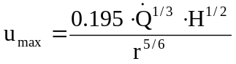 (4.39)

Flame Extensions Under Ceilings
Radial flame extension: 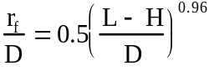 (4.40)

Pressure Profiles and Vent Flows, Well-Ventilated Enclosures
The Bernoulli equation: 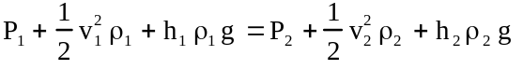 (5.2)
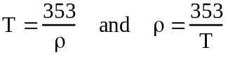 (5.9) Mass flow through thin top vent: 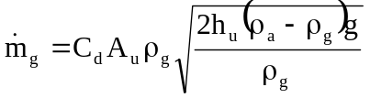 (5.11) Mass flow through thin lower vent: 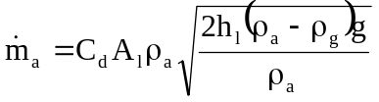 (5.12)

The Well-Mixed Case
Non-constant velocity: 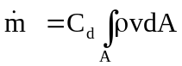
Mass flow rate through upper vent: 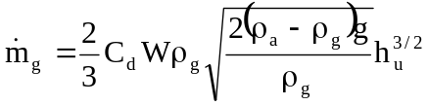 (5.18)
Mass flow rate through lower vent: 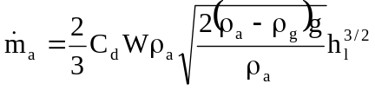 (5.19)
Mass flow into tall opening: 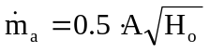 (5.24)

Taking into Account the Mass Produced in the Room
Mass flow rate of ambient air: 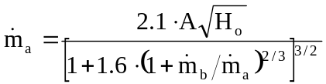 (5.29)

The Stratified Case
Mass flow rate out: 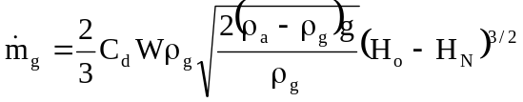 (5.31)
Mass flow rate in: 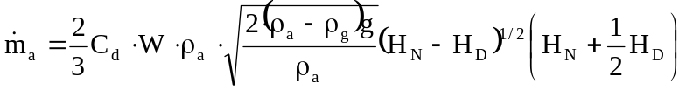 (5.36)

Mass Flow out through a Ceiling Vent
Mass flow: 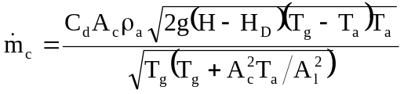 (5.44)

Gas Temperatures in Ventilated Enclosure Fires
Temperature difference: 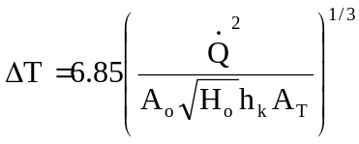 (6.11)
Thermal penetration time: 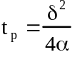 (6.14)
For t < t_{p} 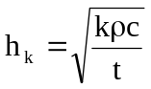 (6.15)
For t ≥ t_{p} 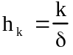 (6.16)
For t < t_{p} 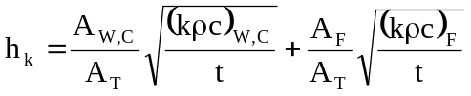 (6.17)
For t ≥ t_{p} 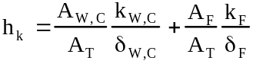 (6.18)
For composite layers: 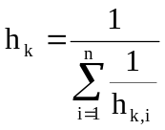 (6.19)

Predicting time to Flashover
Necessary energy release rate: 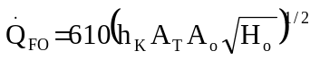 (6.20)
Mechanically ventilated area: 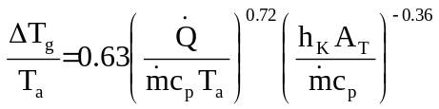 (6.21)

The Energy and Mass Balance
Total energy balance: 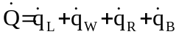 (6.26)
Maximum energy release rate: 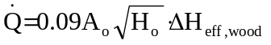 (6.27)
Hot gases leaving: 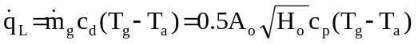 (6.28)
Through walls: 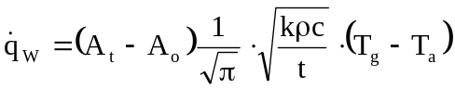 (6.29)
Radiation through opening: 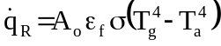 (6.30)

Conservation Equations and Smoke Filling
Gauss’ formula: 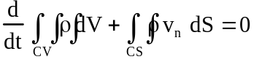 (8.3)
Universal gas law: P = ρ R T (8.12)

The Conservation of Energy
With work: 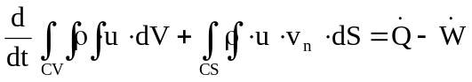 (8.14)
With enthalpy: 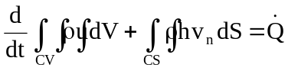 (8.21)
Sealed pressure rise: 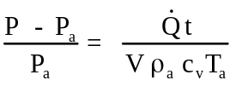 (8.24)
Leaky pressure rise: 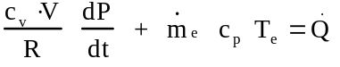 (8.30)
When leakage is stabilized: 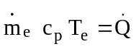 (8.31)
Leaky pressure difference: 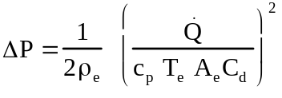 (8.32)

Smoke filling of an Enclosure with Leaks
Dimensionless height: 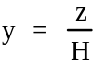 (8.36)
Dimensionless heat release rate: 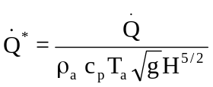 (8.37)
Dimensionless time: 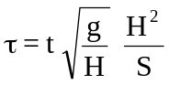 (8.38)
Dimensionless equation: 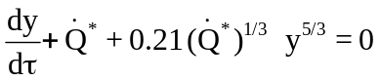 (8.39)
Solution for y: 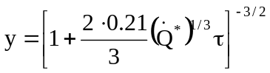 (8.41)

Estimating Gas Temperature for the Floor Leak Case
Energy room size relation: 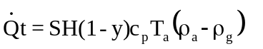 (8.45)
Dimensionless equation: 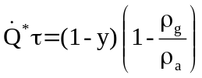 (8.46)

Smoke Control in Large Places
Control constant: 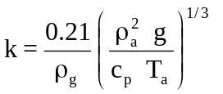 (8.50)
Interface layer height: 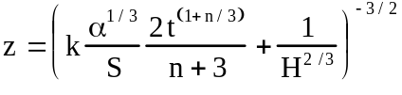 (8.52)
Upper layer density: 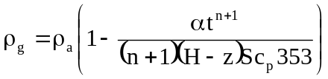 (8.55)
Heat transfer: 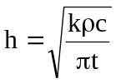 (8.61)
Gas temperature: 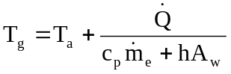 (8.62)

Natural Ventilation from Upper Layer
Pressure difference: 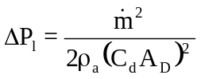 (8.64)
Upper opening mass flow rate: 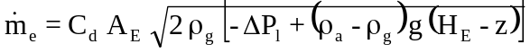 (8.67)

Lower layer Pressurization by Mechanical Ventilation
Pressure difference: 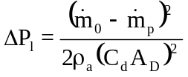 (8.71)
Upper opening mass flow rate: 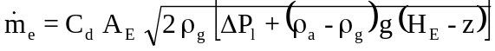 (8.72)

Combustion Products
Yield of species: 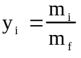 (9.1)
Mass fraction of species: 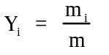 (9.2)
Equivalence ratio: 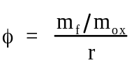 (9.5)
Fuel mixture fraction: 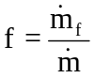
Fuel mixture fraction based on equivalence ratio: 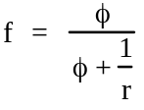 (9.8)
Control volume formulation: 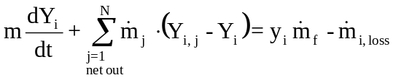 (9.20)
Steady state mass fraction: 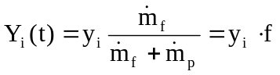 (9.25)
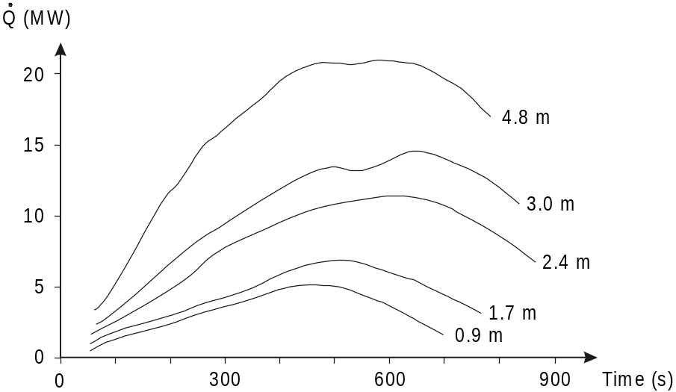
Figure 3.1 Energy release rate measured when burning 1.2 m by 1.2 m wood pallets, stacked to different heights.
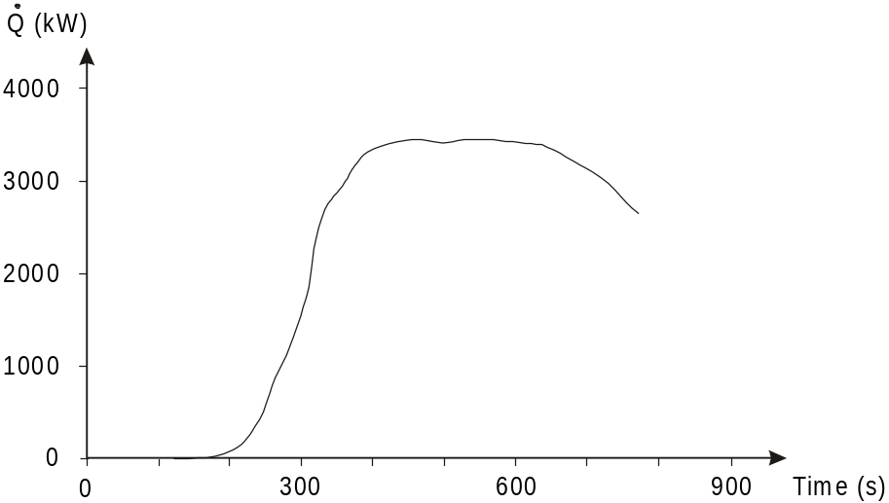
Figure 3.6 Typical Energy Release Rate from a wood pallet stack.
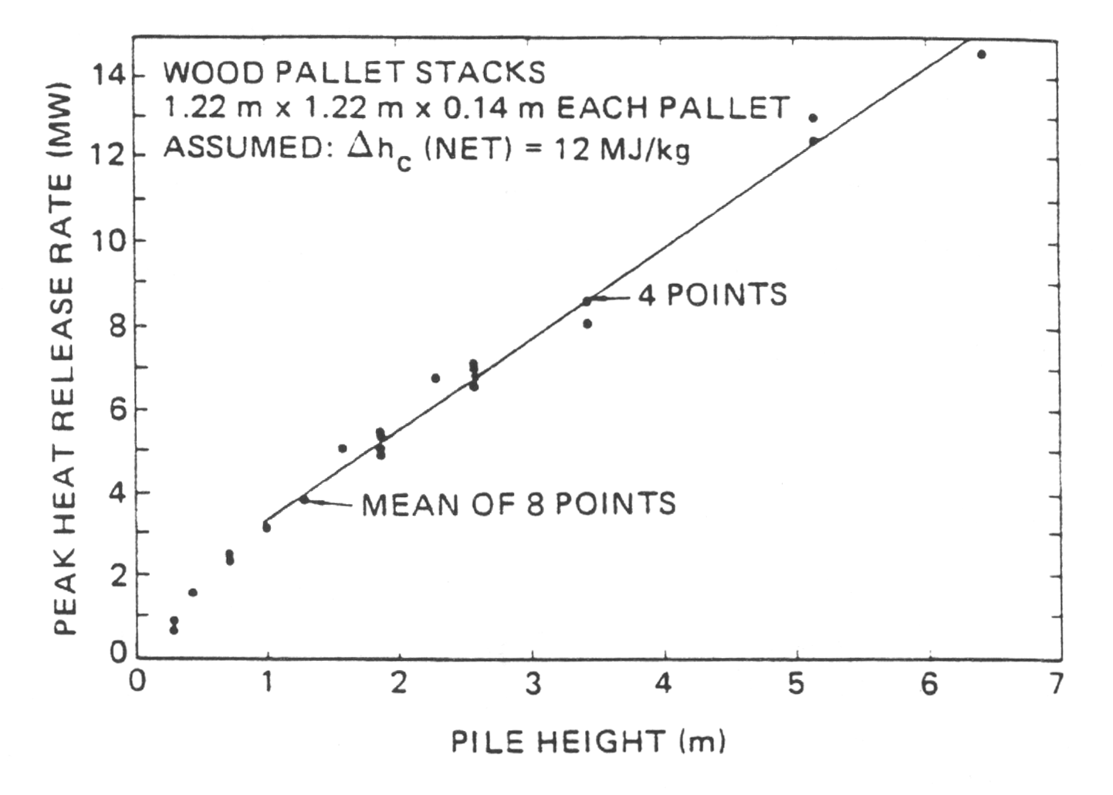

Figure 3.7 Dependence of pallet stack height on peak energy release rate (from Babrauskas [3.1]).
Table 3.2 Burning rate per unit area and complete heat of combustion for various materials (from Tewarson [3.4]).
Material (values in brackets indicate pool diameters tested) | 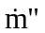 (kg/m²s) | ΔH_{c} (MJ/kg)
Aliphatic Carbon-Hydrogen Atoms:
Polyethylene | 0.026 | 43.6
Polypropylene | 0.024 | 43.4
Heavy fuel oil (2.6 - 23 m) | 0.036
Kerosene (30 - 80 m) | 0.065 | 44.1
Crude oil (6.5 - 31 m) | 0.056
n-Dodecane (0.94 m) | 0.036 | 44.2
Gasoline (1.5 - 223 m) | 0.062
JP-4 (1 - 5.3 m) | 0.067
JP-5 (0.6 - 1.7 m) | 0.055
n-Heptane (1.2 - 10 m) | 0.075 | 44.6
n-Hexane (0.75 - 10 m) | 0.077 | 44.8
Transformer fluids (2.37 m) | 0.025 - 0.030
Aromatic Carbon-Hydrogen Atoms:
Polystyrene (0.93 m) | 0.034 | 39.2
Xylene (1.22 m) | 0.067 | 39.4
Benzene (0.75 - 6.0 m) | 0.081 | 40.1
Aliphatic Carbon-Hydrogen-Oxygen Atoms:
Polyoxymethylene | 0.016 | 15.4
Polymethylmethacrylate, PMMA (2.37 m) | 0.030 | 25.2
Methanol (1.2 - 2.4 m) | 0.025 | 20
Acetone (1.52 m) | 0.038 | 29.7
Aliphatic Carbon-Hydrogen-Oxygen-Nitrogen Atoms:
Flexible polyurethane foams | 0.021 - 0.027 | 23.2 - 27.2
Rigid polyurethane foams | 0.022 - 0.025 | 25.0 - 28.0
Aliphatic Carbon-Hydrogen-Halogen Atoms:
Polyvinylchloride | 0.016 | 16.4
Tefzel™ (ETFE) | 0.014 | 12.6
Teflon™ (FEP) | 0.007 | 4.8
Table 3.3: Data for large pool (D > 0.2 m) burning rate estimates (from Babrauskas [3.1])
Material | Density(kg/m³) | 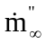 (kg/m²s) | ΔH_{c} (MJ/kg) | kβ (m⁻¹)
Cryogenics:
Liquid H₂ | 70 | 0.017 | 120.0 | 6.1
LNG (mostly CH₄) | 415 | 0.078 | 50.0 | 1.1
LPG (mostly C₃H₈) | 585 | 0.099 | 46.0 | 1.4
Alcohols:
methanol (CH₃OH) | 796 | 0.017 | 20.0 | *
ethanol (C₂H₅OH) | 794 | 0.015 | 26.8 | *
Simple organic fuels:
butane (C₄H₁₀) | 573 | 0.078 | 45.7 | 2.7
benzene (C₆H₆) | 874 | 0.085 | 40.1 | 2.7
hexane (C₆H₁₄) | 650 | 0.074 | 44.7 | 1.9
heptane (C₇H₁₆) | 675 | 0.101 | 44.6 | 1.1
xylene (C₈H₁₀) | 870 | 0.09 | 40.8 | 1.4
acetone (C₃H₆O) | 791 | 0.041 | 25.8 | 1.9
dioxane (C₄H₈O₂) | 1035 | 0.018’’ | 26.2 | 5.4**
diethyl ether (C₄H₁₀O) | 714 | 0.085 | 34.2 | 0.7
Petroleum products:
benzine | 740 | 0.048 | 44.7 | 3.6
gasoline | 740 | 0.055 | 43.7 | 2.1
kerosine | 820 | 0.039 | 43.2 | 3.5
JP-4 | 760 | 0.051 | 43.5 | 3.6
JP-5 | 810 | 0.054 | 43.0 | 1.6
transformer oil, hydrocarbon | 760 | 0.039** | 46.4 | 0.7**
fuel oil, heavy | 940 - 1000 | 0.035 | 39.7 | 1.7
crude oil | 830 - 880 | 0.022-0.045 | 42.5 - 42.7 | 2.8
Solids:
polymethylmethacrylate (C₅H₈O₂)_{n} | 1184 | 0.020 | 24.9 | 3.3
polypropylene (C₃H₆)_{n} | 905 | 0.018 | 43.2
polystyrene (C₈H₈)_{n} | 1050 | 0.034 | 39.7
* Value independent of diameter in turbulent regime. ** Estimate uncertain since only two points available
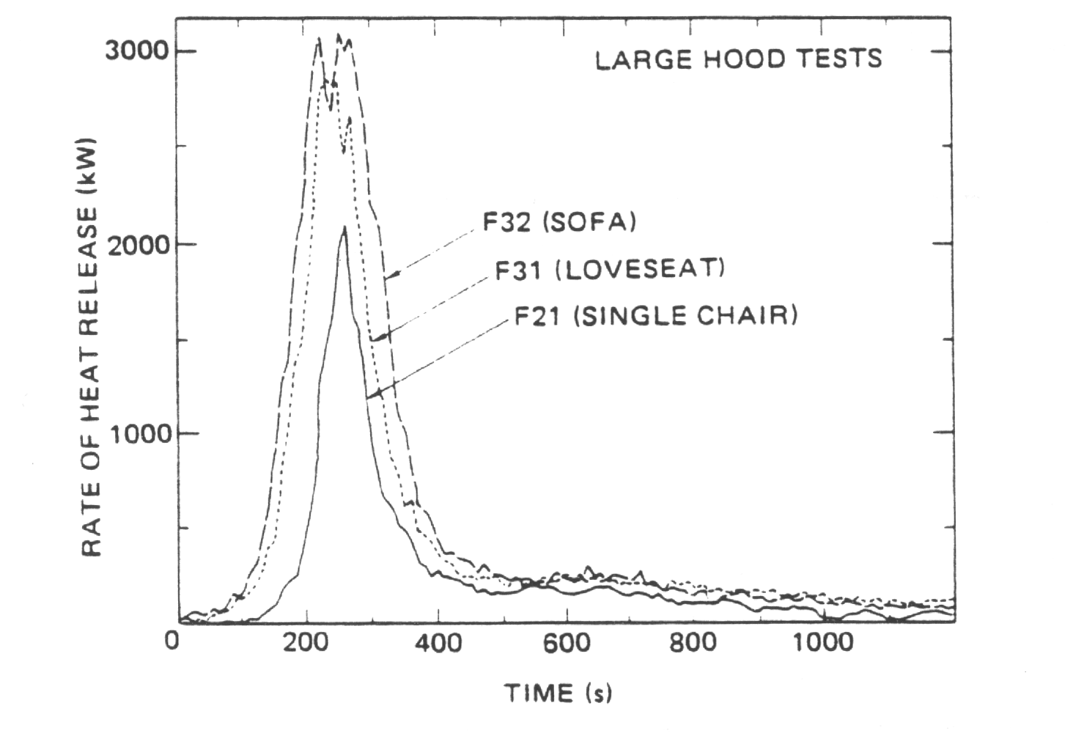
Figure 3.8 Typical upholstered furniture energy release rates (from Babrauskas [3.1]).
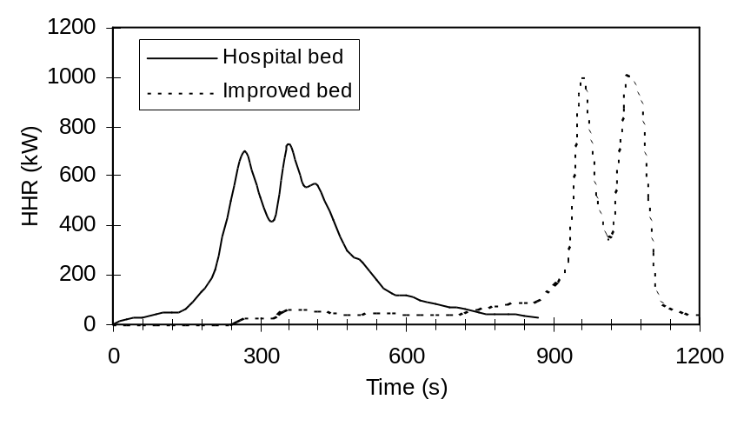
Figure 3.9 Typical mattress energy release rate (from Särdqvist [3.2]).
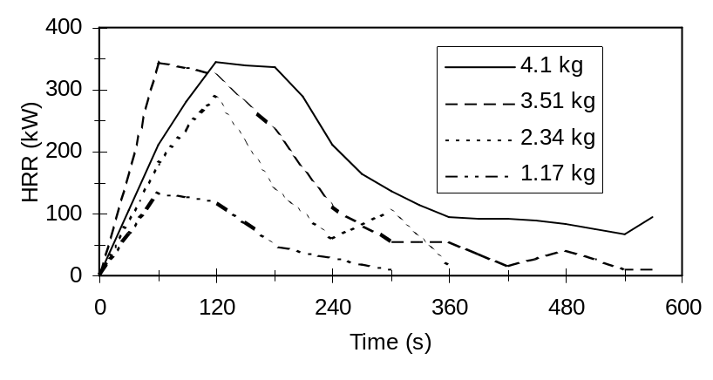
Figure 3.10 Energy release rates for trash bags (adopted from Babrauskas [3.1]).
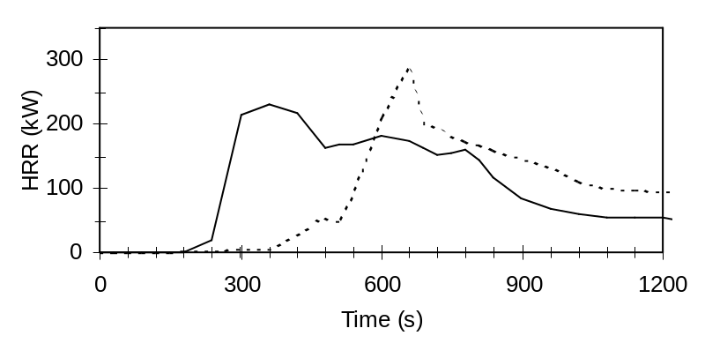
Figure 3.11 Energy release rates from two experiments with television sets (adopted from Babrauskas [3.1])
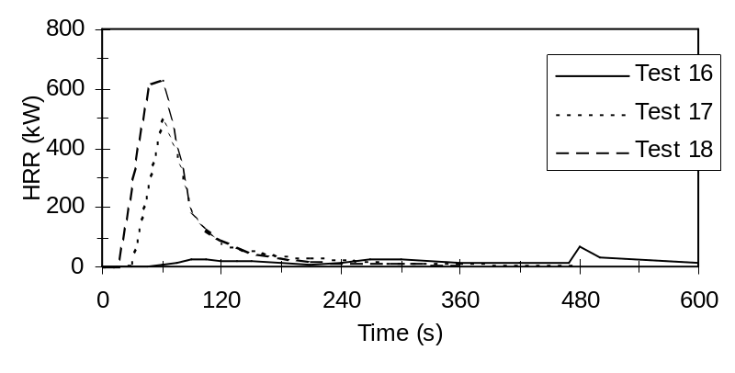
Figure 3.12 Energy release rates from three experiments with Christmas trees (adopted from Babrauskas [3.1]).
Table 3.4: Conversion to Equivalent Fire Load Density and Equivalent Opening Factor
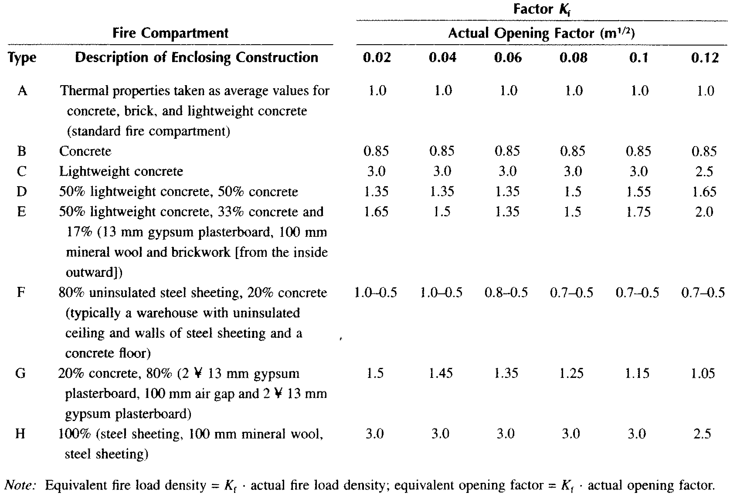

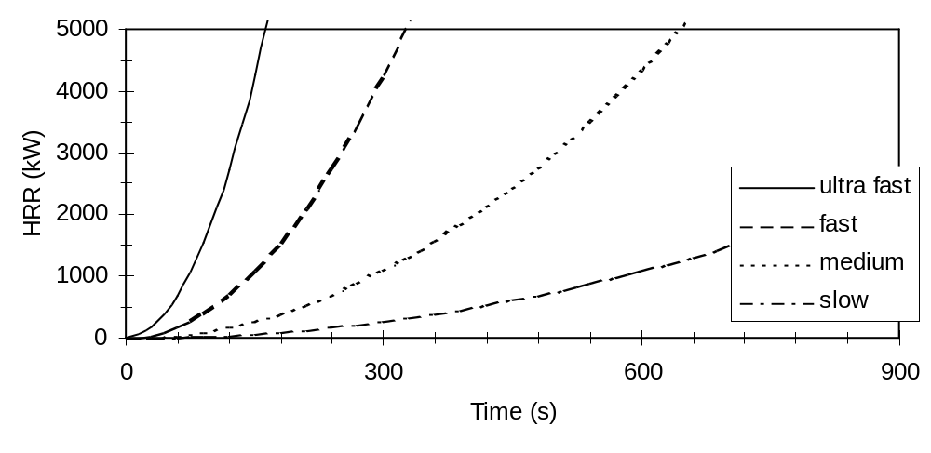
Figure 3.14 Energy release rates for different growth rates.

Table 3.5 Values of α for different growth rates according to NFPA 204M [3.6].
Growth rate | α kW/s² | Time (s) to reach 1055 kW
ultra fast | 0.19 | 75
fast | 0.047 | 150
medium | 0.012 | 300
slow | 0.003 | 600

Table 3.7 Typical growth rates recommended for various types of occupancies.
Type of occupancy | Growth rate α
Dwellings, etc. | medium
Hotels, Nursing homes, etc. | fast
Shopping centers, entertainment centers | ultra fast
Schools, offices | fast
Hazardous industries | Not specified

Table 3.6 Energy release rate data from Nelson [3.7]
Description | Growth rate | kW/m² of floor area
fire retarded treated mattress (including normal bedding) | S | 17
light weight type C upholstered furniture** | M | 170*
moderate weight type C upholstered furniture** | S | 400*
mail bags (full) stored 5 feet high | F | 400
cotton/polyester innerspring mattress (including bedding) | M | 565*
light weight type B upholstered furniture** | M | 680*
medium weight type C upholstered furniture** | S | 680*
methyl alcohol pool fire | UF | 740
heavy weight type C upholstered furniture** | S | 795*
polyurethane innerspring mattress (including bedding) | F | 910*
moderate weight type B upholstered furniture** | M | 1020*
wooden pallets 1 - 1/2 feet high | M | 1420
medium weight type B upholstered furniture** | M | 1645*
light weight type A upholstered furniture** | F | 1700*
empty cartons 15 feet high | F | 1700
diesel oil pool fire (>about 3 Ft. dia.) | F | 1985
cartons containing polyethylene bottles 15 feet high | UF | 1985
moderate weight type A upholstered furniture** | F | 2500*
particle board wardrobe/chest of drawers | F | 2550*
gasoline pool fire ( >about 3 Ft. dia.) | UF | 3290
thin plywood wardrobe with fire retardant paint on all surfaces | UF | 3855*
wooden pallets 5 feet high | F | 3970
medium weight type A upholstered furniture** | F | 4080*
heavy weight type A upholstered furniture** | F | 5100*
thin plywood wardrobe (50in. X 24in. X 72in. high) | UF | 6800*
wooden pallets 10 foot high | F | 6800
wooden pallets 16 foot high | F | 10200
Notes:
* Peak rates of energy release were of short duration. These fuels typically showed a rapid rise to the peak and a corresponding rapid decline. In each case the fuel package tested consisted of a single item.
** The classification system used to describe upholstered furniture is as follows:
LIGHT WEIGHT = Less than about 5 lbs/ft² of floor area. A typical 6-foot long couch would weigh under 75 lbs.
MODERATE WEIGHT = About 5-10 lbs/ft² of floor area. A 6-foot long couch would weigh between 75 and 150 lbs.
MEDIUM WEIGHT = About 10-15 lbs/ft² of floor area. A 6-foot long couch would weigh between 150 and 300 lbs.
HEAVY WEIGHT = More than about 15 lbs/ft² of floor area. A typical 6-foot long couch would weigh over 300 lbs.
Type A = Furniture with untreated or lightly treated foam plastic padding and nylon or other melting fabric.
Type B = Furniture with lightly- or un-treated foam plastic padding or nylon or other melting fabric but not both.
Type C = Furniture with cotton or treated foam plastic padding, having cotton or other fabric that resists melting.


